Westpac Bank

Online Banking (Westpac Classic / Westpac One)

Westpac Classic is the original online banking site developed from a hybrid credit card system with mixed platforms which created numerous design issues. The site was meticulously designed for accessibility and usability where possible. Westpac One is the new responsive online banking website which has addressed many of the constraints of the classic site but has also been less successful in the areas of accessibility and design planning. It’s long term success (or not) will be interesting to follow.

The migration from old to new has been tactical, with only some existing functions migrated so far, and some new functions added. The success of this strategy is also to be determined.

My involvement was in developing new processes in the original site, and then migrating some of these to the new platform when it became available. These are described below.
In my time at Westpac I developed a range of design patterns, especially defensive behaviours, but also scalable touch screen compatible patterns necessary for a truly responsive website. The Westpac online banking site highlighted the benefits of a grid based mobile first approach to responsive design.

I was generally involved from product inception, as product design is critical to the user experience, and products can be designed to make online origination and/or management difficult if not impossible.
I was also involved in much of the writing, not just page navigation/labelling, but also legal and marketing, usually with a view of introducing simple text in plain English. Managing this through the legal hoops is often a challenge.

I am not a trained graphic designer - the Westpac One style was developed externally, however as the project evolved we took on most of the graphics work and developed new patterns as needed.

Tools used:
Balsamiq for wireframing / prototyping
Fireworks / Illustrator for hi-res
Confluence / Jira for collaborative documentation and project management.
LAMP (Linux, Apache, MySQL and PHP) and Javascript for working prototypes and tools

Testing - adhoc and guerilla testing was often used (staff, friends, family, bank customers) as well as formal testing in a test suite. Various testing techniques were used, including open/closed card sorting and paper prototypes.
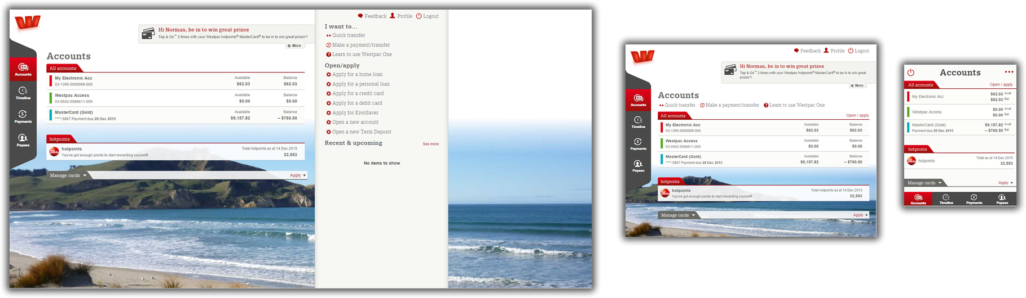

Account originations

Facility to allow customers to open accounts immediately, including joint accounts, PIE accounts and restricted accounts (where they have outstanding identification requirements to meet). Also allows online approval (for joint accounts). Designed originally for the classic site, it allowed the user to select ownership options, account type, other account options (ie attach to cards, statement delivery etc.) and also satisfy the legal requirements. Joint accounts were opened in a restricted state, and the other owners were required to approve the account before it was fully operable. All accounts could be immediately used both online and via an ATM. The Westpac One version used the accordion format developed for the loan application forms (see later).

The accordion pattern has a number of advantages (and disadvantages).
As a means to present a complex series of form sections it works well, allows each section to be fully labelled, including a summary in the tab, and allows sections to be randomly completed. By maintaining a single page view the ‘confirmation’ page is not required, and from a developer point of view there is no need to maintain (and restore) state between pages. It is however a more complex page to build, and dependencies are harder to manage. It adapts well to the mobile screen, and avoids the traditional ‘next/back’ pattern which can be tedious.
Defensive and error management is easier as it can be managed in a single view, and dependencies flagged more quickly.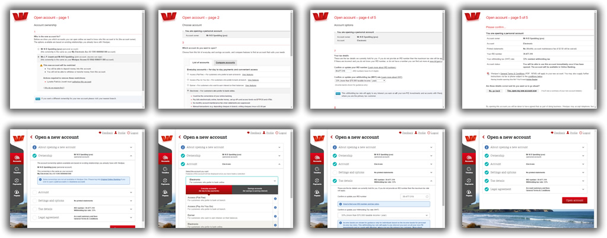

Open, amend and renew Term Deposits
Full creation, viewing and maintenance of Term Deposits. Term deposits are more complex than other accounts as they also require a term, interest repayment and reinvestment instructions to be managed, including terms that mature on non business days and other complexities.
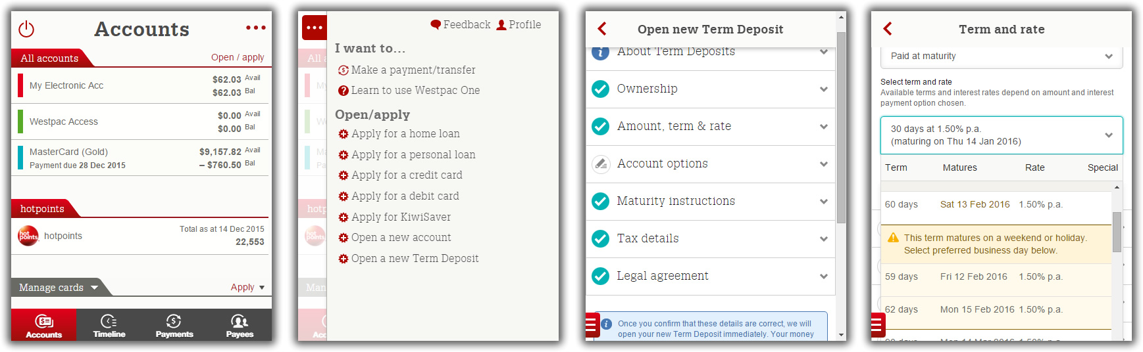

KiwiSaver online origination
Facility to allow customers to sign up for KiwiSaver and select investment portfolio. Later extended to include (government) Default Provider behaviour. I did a lot of work on developing an infographic that would show both KiwiSaver allocation and balance but could not satisfy all product owners to get it implemented. I also did a lot of work on designing interactions to show various fund and risk profiles, including working/interactive models.

Home loan, Personal loan applications
These interactions capture a large amount of data with a view to giving the user an immediate loan application decision. A modular concertina UI approach was selected after testing as offering a number of advantages.
- Translates easily into mobile screen
- Adapts to a variable number of sections
- Random entry/access into any section (not linear)
- Sections can be used separately in different flows, and also adapt well to a user profile section where personal financial data can be held/maintained.
- Section status/summaries show progress and also overall wrap-up.
- Easy access to sections for validation and error handling/highlighting.
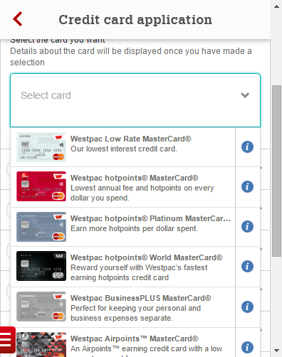
- Easy pause/save and resume (single page), reduced number of round trips.
This pattern adapted well to other origination processes, allowing users to become familiar with the routine.
Of course it’s not without it’s complexities and issues, but has worked well so far.

Credit card application
Similar to account origination, the patterns make use of back-end CMS for content as much as possible. In some cases the same forms are used in both the public (user not identified) and online banking (user verified). In this case the form adapts to the information available.
We did extensive user testing on credit card selection patterns to identify a useful pattern to aid this.

ATM

I consulted with the ATM team extensively, did some camera testing of users and also on-site observation of ATM (and touch screen) behaviour. Developed hybrid FDK/touch displays to work across old/new technology. Also developed best practice guidelines and behaviours. Also designed Direct Currency Conversion (DCC), vendor replacement screens, cardless withdrawal, bill pay and bunch cheque deposit. Consulted with ATM team on a regular basis on wording, behaviours and general usability design issues.

Cash exchange - some mockups below.
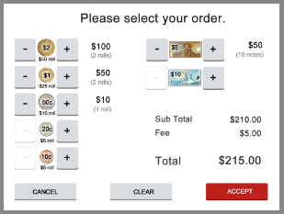
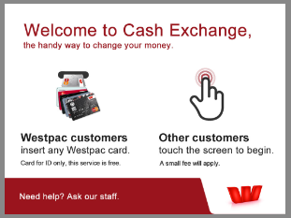
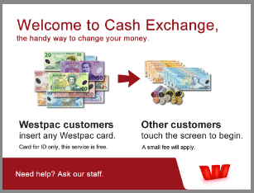
Coupons (vouchers)
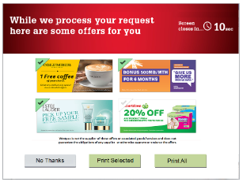

Other

Menu generator
The menu structure for IOLB is hard coded, so documenting all the possible states was onerous, particularly with multiple projects in flight. I developed a web/database tool which allowed all menu permutations for all releases (past and future) to be easily maintained and automatically generated. Both graphical and tabular documentation could be automatically generated. If a project was moved to a different release the documents could be regenerated in a few minutes
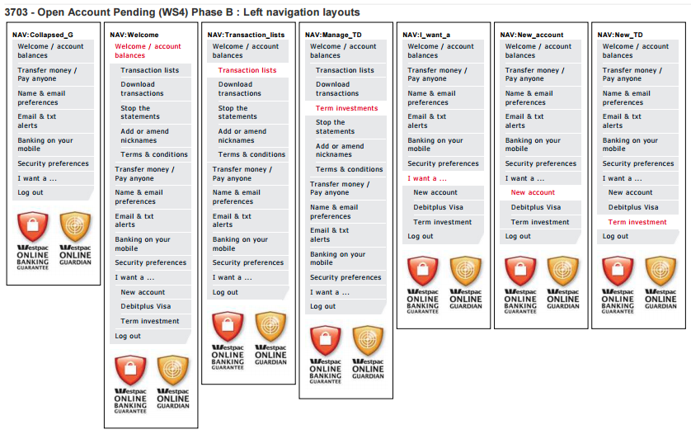
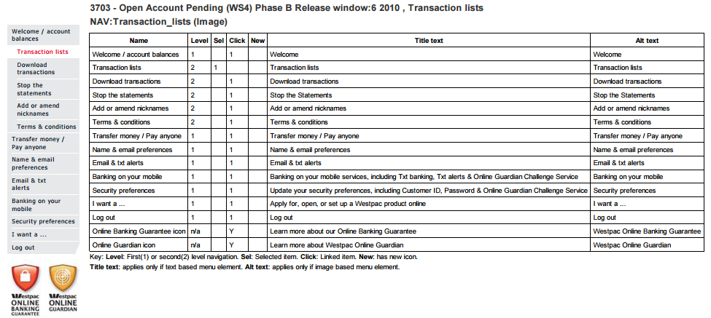

Confluence
Westpac had a laborious paper based system for design documentation which was hugely inefficient and created massive overheads. It was coupled with a heavily managed waterfall development process totally at odds with the rapidly changing technology it was trying to support. We introduced an electronic design documentation system based on Confluence and Jira. This was gradually adopted by other groups including IT, project managers and other business groups. Unfortunately it did not break into the legal area which still persists in a paper document paradigm. It also has been a victim of it’s own success. By being adopted as a corporate platform it became to expensive to license the add-ons required for design work, so it’s original functions have been largely abandoned and it’s potential never fully realised.

Home Club
The goal was to create a resource for home buyers which would then funnel them into Westpac Home Loan.
Very poorly implemented website - some concepts were well intentioned but classic mistake of taking an ‘artists concept’ and trying to build it with no analysis or design behind it. Even the site owners did not know what some sections were trying to achieve or the message that was being delivered. As a result it required a lot of remedial work to make it functional. Site was retired.

Metservice

My initial entry into Metservice was to manage a small number of specific web sites, such as a site used by the Americas Cup syndicates for accessing and sharing their own and Metservice weather data.

I was asked to develop and International weather site capable of being configured to individual customers needs. After reviewing various CS systems which are generally not designed to manage real time data, highly graphical data presentation, and configurable time zones and data units, I decided to develop an engine which became the basis for most of the design work I subsequently carried out.

An early prototype of this engine was used to develop a speculative mobile weather site for the innovative Vodafone Live mobile multimedia application (pre smartphone). This site became the posterchild for the mobile application and won a national award for mobile content.

The Metraweather site gained a few international customers, however the real strength of the platform became apparent when I migrated the New Zealand B2B site Metconnect onto the engine. The engine allowed pages to be quickly built using templates and configuration tools, often in the presence of the customer to confirm the design. New templates, units and data sets are easily added to meet customers needs, and take customers closer to the decisions they wanted to make, including specialist business rules (road marking, hay making, power generation, WRC etc.). This site won several awards for both technology and customer service.

The engine is based on the LAMP (Linux, Apache, MySQL and PHP) platform with Javascript and Flex (Flash) used on client side.

The administration interface uses the same interface and allows the marketers to set up, personalise and configure customer products on the fly, with a variety of subscription and alerting options. We also created a multiple server load balancing backend to handle the loads (exceptional during bad weather), and I included various load management and dynamic caching features to reduce overhead activities during peak loads.

Variations (clones) of the site were used to create specialist sites for volcanic activity information (CAA).

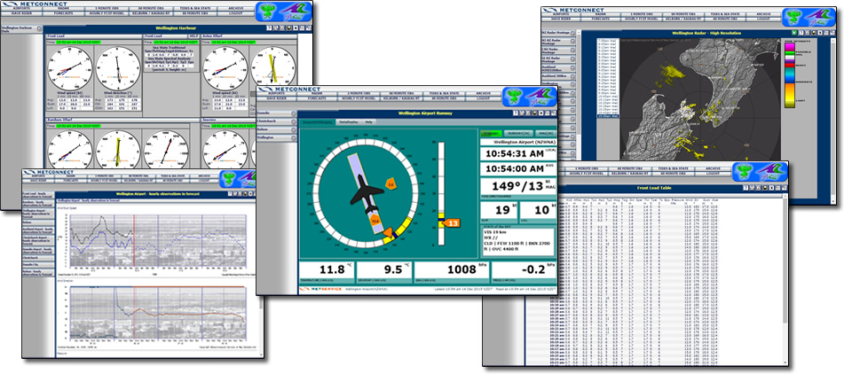

The Metservice public site was regarded as a non revenue earning static site built to satisfy government contracts. Data presentation was minimal, predicated that users with money would pay for better service/content. We managed to convince the management that creating a much more friendly and usable site, and giving away more weather data would create better returns via advertising. The resulting site presented rich weather information in a highly graphical and compact form. It was in essence a single client of the Metconnect engine, even though it was the 10t busiest site in New Zealand. The structure also allowed users to build their own weather pages, with every weather element on the site available to be added and arranged on multiple pages - the ultimate customisation.
